 | Artikel nummer | omschrijving/description | aantal |  | quantity |  |  |  |  | Totaal |  |  |  | Foto/Photo |  |  |  |  | consumenten |  |  |  |  |  |  | Totaal
 | /Article number |  |  |  |  |  |  |  |  |  |  |  |  |  |  | prijs /
 | /Article number |  |  |  |  |  |  |  |  |  |  |  |  |  |  |  |  |  |  |  | consumenten
 |  |  |  |  |  |  |  |  |  |  |  |  |  |  |  | consumer
 |  |  |  |  |  |  |  |  |  |  |  |  |  |  |  |  |  |  |  |  | prijs / Total
 |  |  |  |  |  |  |  |  |  |  |  |  |  |  |  | price
 |  |  |  |  |  |  |  |  |  |  |  |  |  |  |  |  |  |  |  |  |  |  | consumer
 |  |  |  |  |  |  |  |  |  |  |  |  |  |  |  |  |  |  |  |  |  | price
 |  | Cosmetisch setjes 5 delig /Brush set, 5 pcs
 | B* 11116 | into PVC pouch. Packaging in opp bag with |  | 6.357 |  | € |  |  |  |  |  |  |  |  |  | € |  | 2,49 |  |  | € |  | 15.828,93
 |  | header card and barcode.
 |  | Poederkwast kort / Powder brush-short,
 | D* 34-64600 | color light brown. Packaging on black |  | 353 |  | € |  |  |  |  |  |  |  |  |  | € |  | 8,99 |  |  | € |  | 3.173,47
 |  | plastic cards with barcode.
 |  | Blusherkwast schuin / Blusher brush
 | D* 34-64602 | medium goat hair color light |  | 305 |  | € |  |  |  |  |  |  |  |  |  | € |  | 7,99 |  |  | € |  | 2.436,95
 | D* 34-64602 | brown.Packaging on black plastic cards
 |  | with barcode.
 |  | Masker/foundation kwast - Foundation
 | D* 34-64603 | brush nylon hair color light brown. |  | 62 |  | € |  |  |  |  |  |  |  |  |  | € |  | 9,99 |  |  | € |  | 619,38
 | D* 34-64603 | Packaging on black plastic cards with
 |  | barcode.
 |  | Wimper- wenkbrauwkam/borstel -
 | D* 34-64604 | Eyebrow comb/brush. Packaging on black |  | 692 |  | € |  |  |  |  |  |  |  |  |  | € |  | 4,99 |  |  | € |  | 3.453,08
 |  | plastic cards with barcode.
 |  | Oogschaduwpenseel schuin - Eyeshadow
 | D* 34-646405 | brush nylon hair, color light brown. |  | 700 |  | € |  |  |  |  |  |  |  |  |  | € |  | 4,99 |  |  | € |  | 3.493,00
 | D* 34-646405 | Packaging on black plastic cards with
 |  | barcode.
 |  | Applicator verwisselbare tip - Foam
 | D* 34-64606 | applicator (changable tip) color |  | 1.186 |  | € |  |  |  |  |  |  |  |  |  | € |  | 4,99 |  |  | € |  | 5.918,14
 | D* 34-64606 | black/white. Packaging on black plastic
 |  | cards with barcode.
 |  | Set reserve tips voor applicator 64606 -
 | D* 34-64607 | Foam applicator (4 pcs) black/white, in |  | 1.957 |  | € |  |  |  |  |  |  |  |  |  | € |  | 4,99 |  |  | € |  | 9.765,43
 | D* 34-64607 | transparant pvc. Packaging into clam shell
 |  | with inlay card with barcode.
 |  | Uitschuifbare poederkwast - Retractable
 | D* 34-64610 | powder brush, medium goat hair, color |  | 788 |  | € |  |  |  |  |  |  |  |  |  | € |  | 9,99 |  |  | € |  | 7.872,12
 | D* 34-64610 | light/brown. Packaging on black plastic
 |  | cards with barcode.
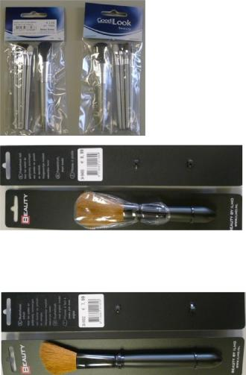
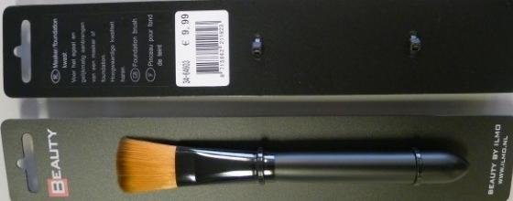
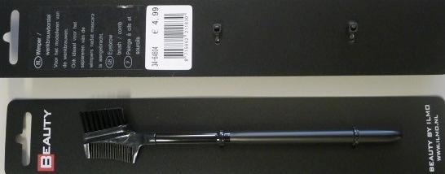
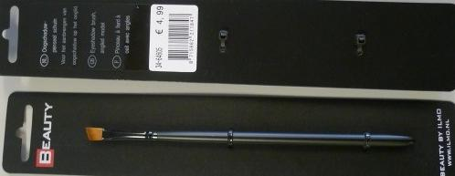
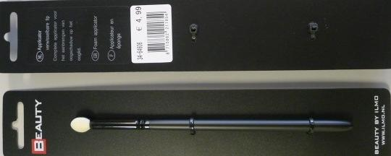
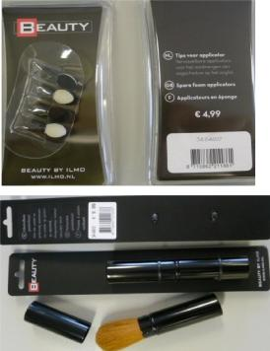
 | Set 5 applicators dubbelzijdig - Set of 5
D* 34-64612 | applicators in transparant pvc holder. | 635 |  |  |  |  |  | € | 4,99 | € | 3.168,65
D* 34-64612 | Packaging into clam shell with inlay card
 | with barcode.
 | Kabuki kwast - Kabuki brush, medium goat
D* 34-64613 | hair, light brown. Each brush into plastic | 612 |  |  |  |  |  | € | 9,99 | € | 6.113,88
 | box, with inlay with barcode.
 | Shading kwast - Fan brush, medium goat
D* 34-64615 | hair, light brown color. Packaging on black | 1.250 |  |  |  |  |  | € | 7,99 | € | 9.987,50
 | plastic cards with barcode.
 | Concealer/foundation kwast - Concealer
D* 34-64616 | foundation brush, nylon hair light brown | 1.220 |  |  |  |  |  | € | 7,99 | € | 9.747,80
D* 34-64616 | color. Packaging on black plastic cards with
 | barcode.
M* 4705 | Ooghaar-krullers plastic - Eyelash curler, | 12.088 |  |  |  |  |  | € | 1,96 | € | 23.692,48
M* 4705 | plastic: white & pink
M* 62673 | Saffier nagelvijl 6", wit - nail file 6" white | 550 |  |  |  |  |  | € | 1,15 | € | 632,50
M* 62673 | handle.
T* B71-1BL | Schaar 18 cm, roestvast staal - household | 1.546 |  |  |  |  |  | € | 2,95 | € | 4.560,70
T* B71-1BL | scissors 18 cm, stainless steel
B* 5018 | Retractable powder brush, mat | 942 |  |  |  |  |  | € | 2,25 | € | 2.119,50
B* 5018 | silver/chrome
 | Haarborstel met platic pinnen, Middle oval
B* 4211 | shaped hairbrush with plastic pins. Barcode | 482 |  |  |  |  |  | € | 2,95 | € | 1.421,90
 | label on brush head (see photo).
 | Plastic tonnetje met 48 pincetten assorti / |  |  |  |  |  |  | € | 1,98 /
W*1 | Plastic tonnetje met 48 pincetten assorti / | 265 |  |  |  |  |  | (pincet- |  | € | 25.185,60
W*1 | pastic box with 48 tweezers |  |  |  |  |  |  |  |  | € | 25.185,60
 | pastic box with 48 tweezers |  |  |  |  |  |  | tweezers)
W*2 | 75 hairbands into opp bag with barcode | 5.997 |  |  |  |  |  | 6,20 / bag. |  | € | 37.181,40
W*2 | label (assortie zwart/zilver, bruin en beige) |  |  |  |  |  |  |  |  | € | 37.181,40
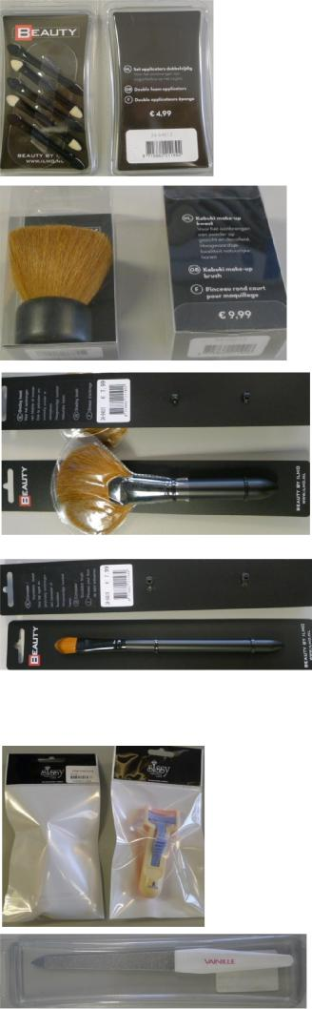
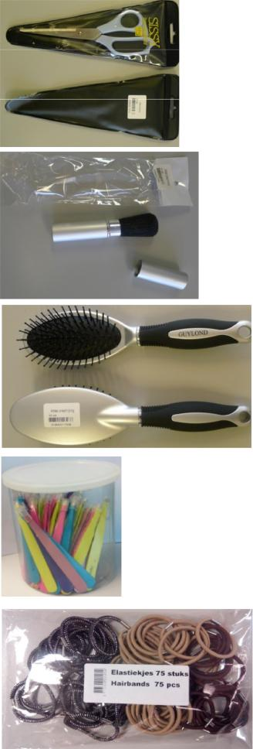
A* 5010 | Anti luizenhoes voor school, Housse anti- | 5.757 |  | € | 4,99 | € | 28.727,43
A* 5010 | poux pour L'école | 5.757
st 1107 | Eyeliner / á lévres | 861 |  | € | 4,99 | € | 4.296,39
st 1117 | Retractable blusher brush / Piceau à fard à | 177 |  | € | 7,99 | € | 1.414,23
st 1117 | joues coulissant | 177
st 6195 | Grooming nailfile 4-steps / Lime à ongles à | 597 |  | € | 1,99 | € | 1.188,03
st 6195 | 4 faces | 597
st 6192 | Grooming nailfile 2-steps / Lime à ongles à | 273 |  | € | 1,99 | € | 543,27
st 6192 | 2 faces | 273
st 8112 | Guylond facial buffer sponge / Scrub spons | 142 |  | € | 2,99 | € | 424,58
st 8112 | 100x70x25 mm | 142
st 11024B | Douglas Retractable lipliner DP01H, brown | 1.088 |  | € | 4,99 | € | 5.429,12
st 11024B | takelon hair | 1.088
st 11051 | Douglas Set of 5 applicators AP34 | 3.359 |  | € | 3,99 | € | 13.402,41
st 11051 | sponge/sponge | 3.359
st 11053 | Douglas Set of 5 applicator AP24 | 2.661 |  | € | 3,99 | € | 10.617,39
st 11053 | shadow/lipbrus | 2.661
St 72001B | Super powder brush Big / thick wooden | 127 |  | € | 8,99 | € | 1.141,73
St 72001B | handle. Proffessional quality. | 127
St 72004H | Make-up brush large - medium wooden | 210 |  | € | 7,99 | € | 1.677,90
St 72004H | handle | 210
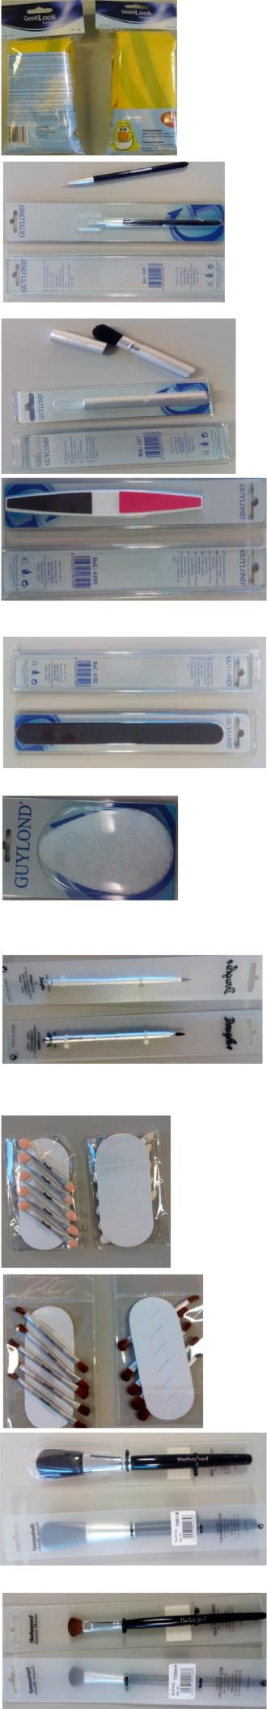
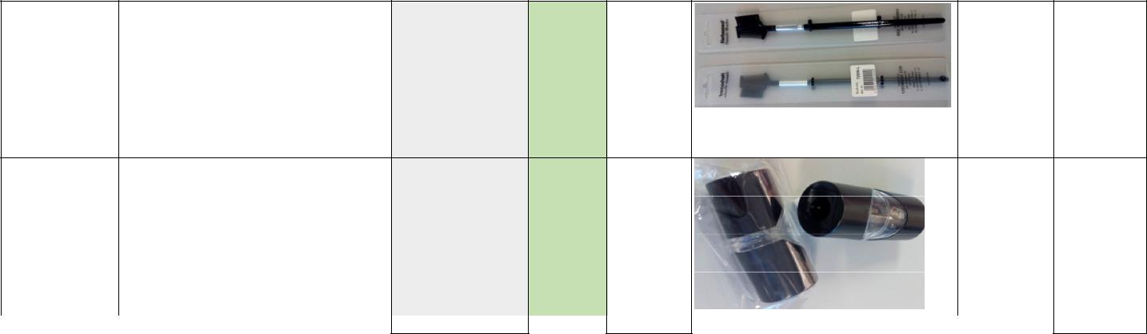
st 72006L | Eyebrow brush with comb - Thin handle |  |  | € | 4,99 € | 578,84

 | Pencil sharper double with transparent ring
st 6177 | /Puntenslijper dubbel voor cosmetische |  | 1.499,25 |  |  | € |  | 1,99 € | 11.934,03
 | penselen.
 |  | 59.352 |  | € | 42.332,86 |  |  |  |  | € |  | 257.747,76

